______________’s daily chart

Monday | Tuesday | Wednesday | Thursday | Friday
Morning routine  15 minutes math  15 minutes reading  Chore: | Morning routine  15 minutes math  15 minutes reading  Chore: | Morning routine  15 minutes math  15 minutes reading  Chore: | Morning routine  15 minutes math  15 minutes reading  Chore: | Morning routine  15 minutes math  15 minutes reading  Chore:

Morning routine:
- Check bed
- Brush teeth
- Dressed and pjs in washer
- Daven
- Check chore, plan when to do it
- Breakfast

___________’s daily chart

Monday | Tuesday | Wednesday | Thursday | Friday
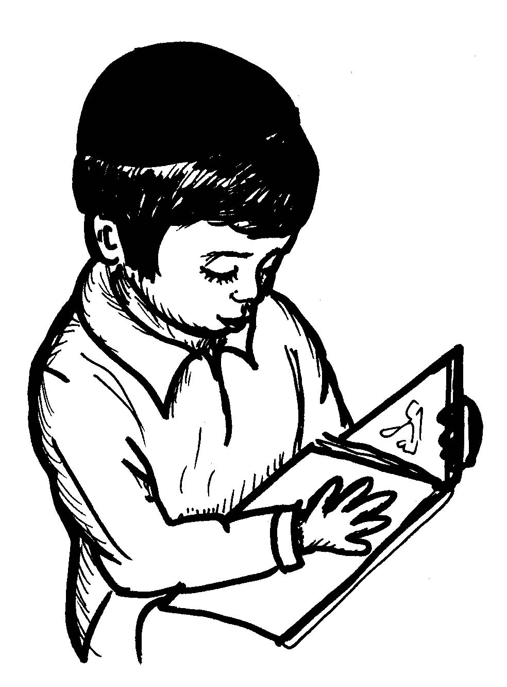  Chore: | Chore: | Chore: | Chore: | Chore:

